**Lou Harrison’s *Concerto for Piano with Javanese Gamelan****, III*Name:____________

Lou Harrison’s *Concerto for Piano with Javanese Gamelan* was written in 1987 and premiered at Mills College on Lou Harrison’s seventieth birthday. It does not use a complete gamelan, and is based loosely on a baroque concerto form. His score uses cipher notation for the Javanese instruments, with each number representing on rhythmic beat in the metric structure of the work. His notation relies on trained gamelan musicians the freedom to create melodic embellishments (*glossary below). Listen to the recording on Playlist 2, look at the score, and answer the following questions about this movement.

*Form*

1. How would you characterize the form of this movement in Western terms?

2. The cipher notation for movement III, “Belle’s Bull” indicates two main sections: how many beats does each contain? (Together they make the same form as *Wilujeng* from Playlist 1). One of these sections is unbalanced with relation to the other; how do these sections capture both a Javanese and a Western sense of form? (I have placed a red arrow on p. 4 of the score where the first movement’s introduction returns to usher in the final section of movement III.)

3. What do you call any section punctuated by a gong?

*Pitch and tuning*

4. The movements are either in sléndro or pélog tunings. Which is found in “Belle’s Bull” (NB: there is an extra note in piano not found in the gamelan)? How do the two tunings relate to one another (represented in EQTET below)?

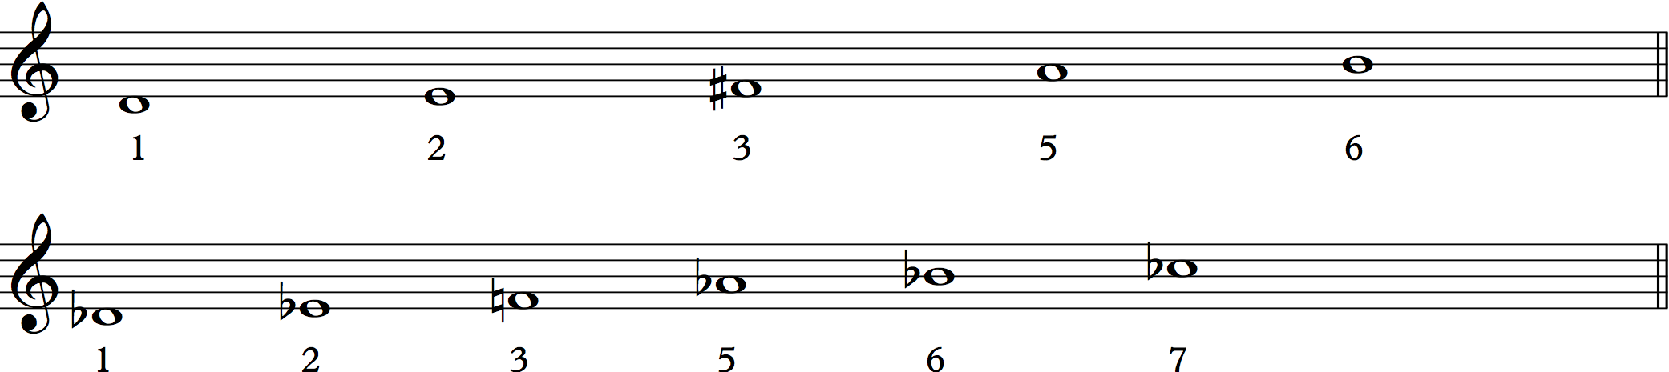

5. Which tetrachord (four notes) predominates in the piano as a melodic motive?

*Rhythm & Melody*

6. In traditional gamelan the relationship between the accompaniment and the balungan (melody) is expressed in multiples of two. What are these levels of rhythmic subdivision called?

7. This concept can be represented in Western notion by the duration of the prevailing beat (= melody tone). What is the value of the beat throughout movement III?

8. What is different about the two gong strokes punctuating this movement?

9. Below is a segment of the cipher notation for movement II (q=beat). You will notice that here the elaboration of the balungan is written out for the saron. This maybe because of a strange rhythmic-structural element that doesn’t fit traditional gamelan forms; can you find it?

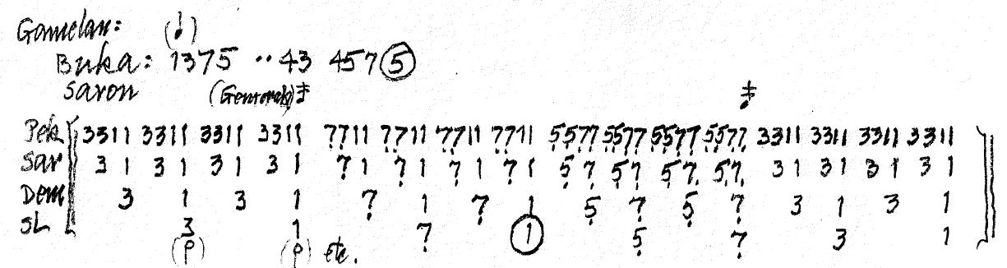

10. Sum up movement III by noting at least one Western and one Indonesian element each about its pitch structure, form (or formal development) and rhythmic/metric structure.

*Saron: metallophone in three sizes: demung, barung and peking (= panerus)

imbal: repetitive melodic structure composed of interlocking parts

bonang: 10, 12, 0r 14 tuned kettle gongs in horizontal frame in two rows, in three sizes: panembung, barung and panerus.

T: kethuk, small knobbed gong

P: kempul, medium hanging gong

N: kenong, high-pitched gong

Ng.: ngelik, second section of ladrang form, higher-pitched than first

Pek.: peking

Sar: saron

Dem: demung

SL: slenthem

mipil: elaboration technique for bonang which involves improvising on two-note pairs of balungan

O: gong tone