Theory (55%) NAME:
I. Basic Operations: A series is traditionally used in four different orderings: prime (P), inversion (I), retrograde (R), and retrograde-inversion (RI). Each of these four orderings may begin on any of the twelve pitch classes. Use the following twelve-tone series in answering the succeeding questions, and assume that each one is a P-form.
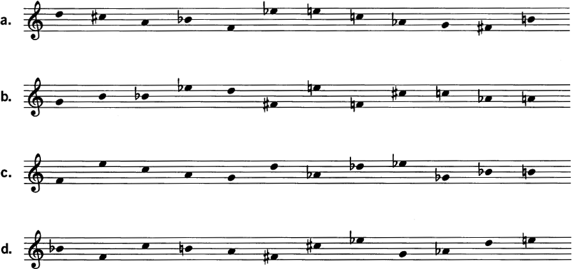
1. For each of the notated series, write the following series forms. (Give your answer both in integers and in staff notation.)
a. P₇
b. R₁₀
c. RI₆
d. I₅
2. Each of the following series is a transformation of one of the four given above. Identify the series and the transformation.
a. 7, 6, 2, 11, 9, 4, 10, 3, 5, 8, 0, 1 :
b. 3, 4, 8, 7, 0, 2, 1, 5, 9, 10, 11, 6 :
c. 4, 6, 0, 1, 5, 7, 2, 11, 9, 8, 3, 10 :
d. 8, 7, 11, 0, 4, 3, 5, 1, 2, 9, 10, 6 :
3. For each of the notated series, construct a 12 X 12 matrix. Using the matrix, check your answers to the previous questions.
a | b
c | d

4. Indicate whether the following statements are true or false. (If false, make the necessary correction.)
a. The prime and retrograde-inversion have the same intervals in reverse order.
b. The inversion and retrograde-inversion have complementary intervals in reverse order.
c. The retrograde and inversion have complementary intervals in the same order.
II. Subset Structure: The constituent groupings within a series are its subsets.
1. For each of the notated series, identify the set classes to which the following belong:
a. the discrete trichords
a. b. c. d.
b. the discrete tetrachords
a. b. c. d.
c. the discrete hexachords
a. b. c. d.
III. Invariants: Any musical object or relationship preserved under some operation is an invariant.
1. For the series from Schoenberg's String Quartet No. 4, (D–C#–A–B^{b}–F–E^{b}–E–C–A^{b}–G–F#–B), identify the series forms that preserve the following segments:
a. (G, F#, B) b. (B^{b}, F, E^{b}) c. (D, C#, A, B^{b})

2. For the series from Webern's Concerto for Nine Instruments, op. 24, (G–B–B^{b}–E^{b}–D–F#–E–F–C#–C–A^{b}–A), identify the series forms that preserve the discrete trichords.

IV. Derivation: A derived series is one whose discrete segmental trichords or tetrachords are all members of the same set class.
1. The following series by Webern are derived. Identify the generating trichord or tetrachord and the transformations (transposition, inversion, retrograde) that connect it with the other segmental subsets of the series.
a. C#–C–E^{b}–D–F#–G–E–F–A–A^{b}–B–B^{b} (String Quartet, op. 28)
b. E^{b}–B–D–C#–F–E–G–F#–B^{b}–A–C–A^{b} (Cantata I, op. 29)

Analysis. Elisabeth Lutyens, Motet Op. 27, from Wittgenstein’s Tractatus Logic-Philosophicus (25%)
Listen to this piece here (youtube link)
Text of excerpt:
1. Die Welt ist allés, was der Fall ist.  1.1 Die Welt ist die Gesamtheit der Tatsachen. ...  1.13 Die Tatsachen im logischen Raum sind die Welt. | 1. The world is all that is the case.  1.1 The world is the totality of facts. ...  1.13 Facts in logical space are the world.

1. Take the following as the twelve-tone reference series for the piece, broken up into hexachords: P₂ = D–D^{b}–F–A–B^{b}–G^{b}/ E–A^{b}–G–E^{b}–B–C. Locate these two hexachords in the work’s opening phrase. What do you notice about the presentation of the second hexachord?

2. What do you notice about the structure of the first melody in alto? What does this tell you about the underlying unordered set? Give the first hexachord in normal form. Give the second hexachord in normal form.

3. Give the original row in its form as I₇. How does the pitch content of I₇ relate to that of P₂?

4. The I₇ row is first located in the bass, but what is odd about its presentation? Where is the second half of I₇? How is the second hexachord presented?

5. Analyze the vertical tetrachords formed by the first three chords in m. 7. What do you notice about their progression?

6. Analyze the Normal Form of the vertical hexachord at “Welt.” There are several ways to relate that to a segment of the row; give at least one row form that will produce those six pitch-classes.

7. Lutyens claimed that all of her rows were based on 3-note cells. What cell is used to construct the Motet?

8. How might the text relate to the idea behind the music? Extra credit: Can you find anything that links all the appearences of “Welt,” “Fall,” “Gesamtheit” or “Raum”?

Webern, Concerto for Nine Instruments, Op. 24, iii, mm. 1–13 (20%)
The second movement of this concerto has been discussed many times in this book. The third movement, excerpted here, maintains the intervallic and trichordal focus of movement ii.

1. P₅ = F–F#–D–C#–A–B^{b}–A^{b}–C–B–E–E^{b}–G. Analyze the series, with particular attention to its intervals, discrete trichords, and hexachords. Do a twelve-count of the passage, identifying its row forms.

2. The series is derived from a trichord. Identify occurrences of that trichord and relate them via T_{n} and I_{n} . Do you see any patterns?

3. The passage can be thought of as two separate lines (as in the reduced score). Analyze the relationship between the lines, both in pitch and in rhythm.

4. Study the invariance among the series forms and describe how it is manifested in the music.

5. Other than the poco ritenuto and the rest at the end, what gives this passage the sense of a single formal section, with a beginning, middle, and end?

