NAME:
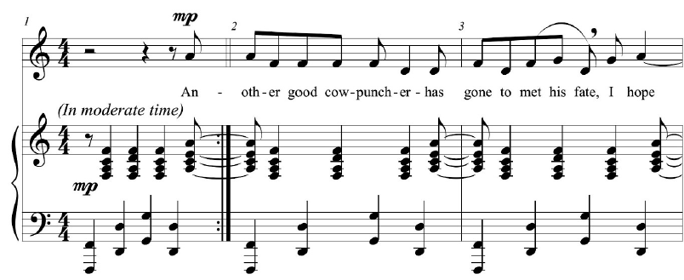
1. “Charlie Rutledge,” Charles Ives

Describe the relationship of the chords in the treble clef of the piano accompaniment in mm. 1–3 using NRT relations. Is there a complete cycle (refer to the tonnetz)?

Trace the pattern on this tonnetz, beginning on (E-)

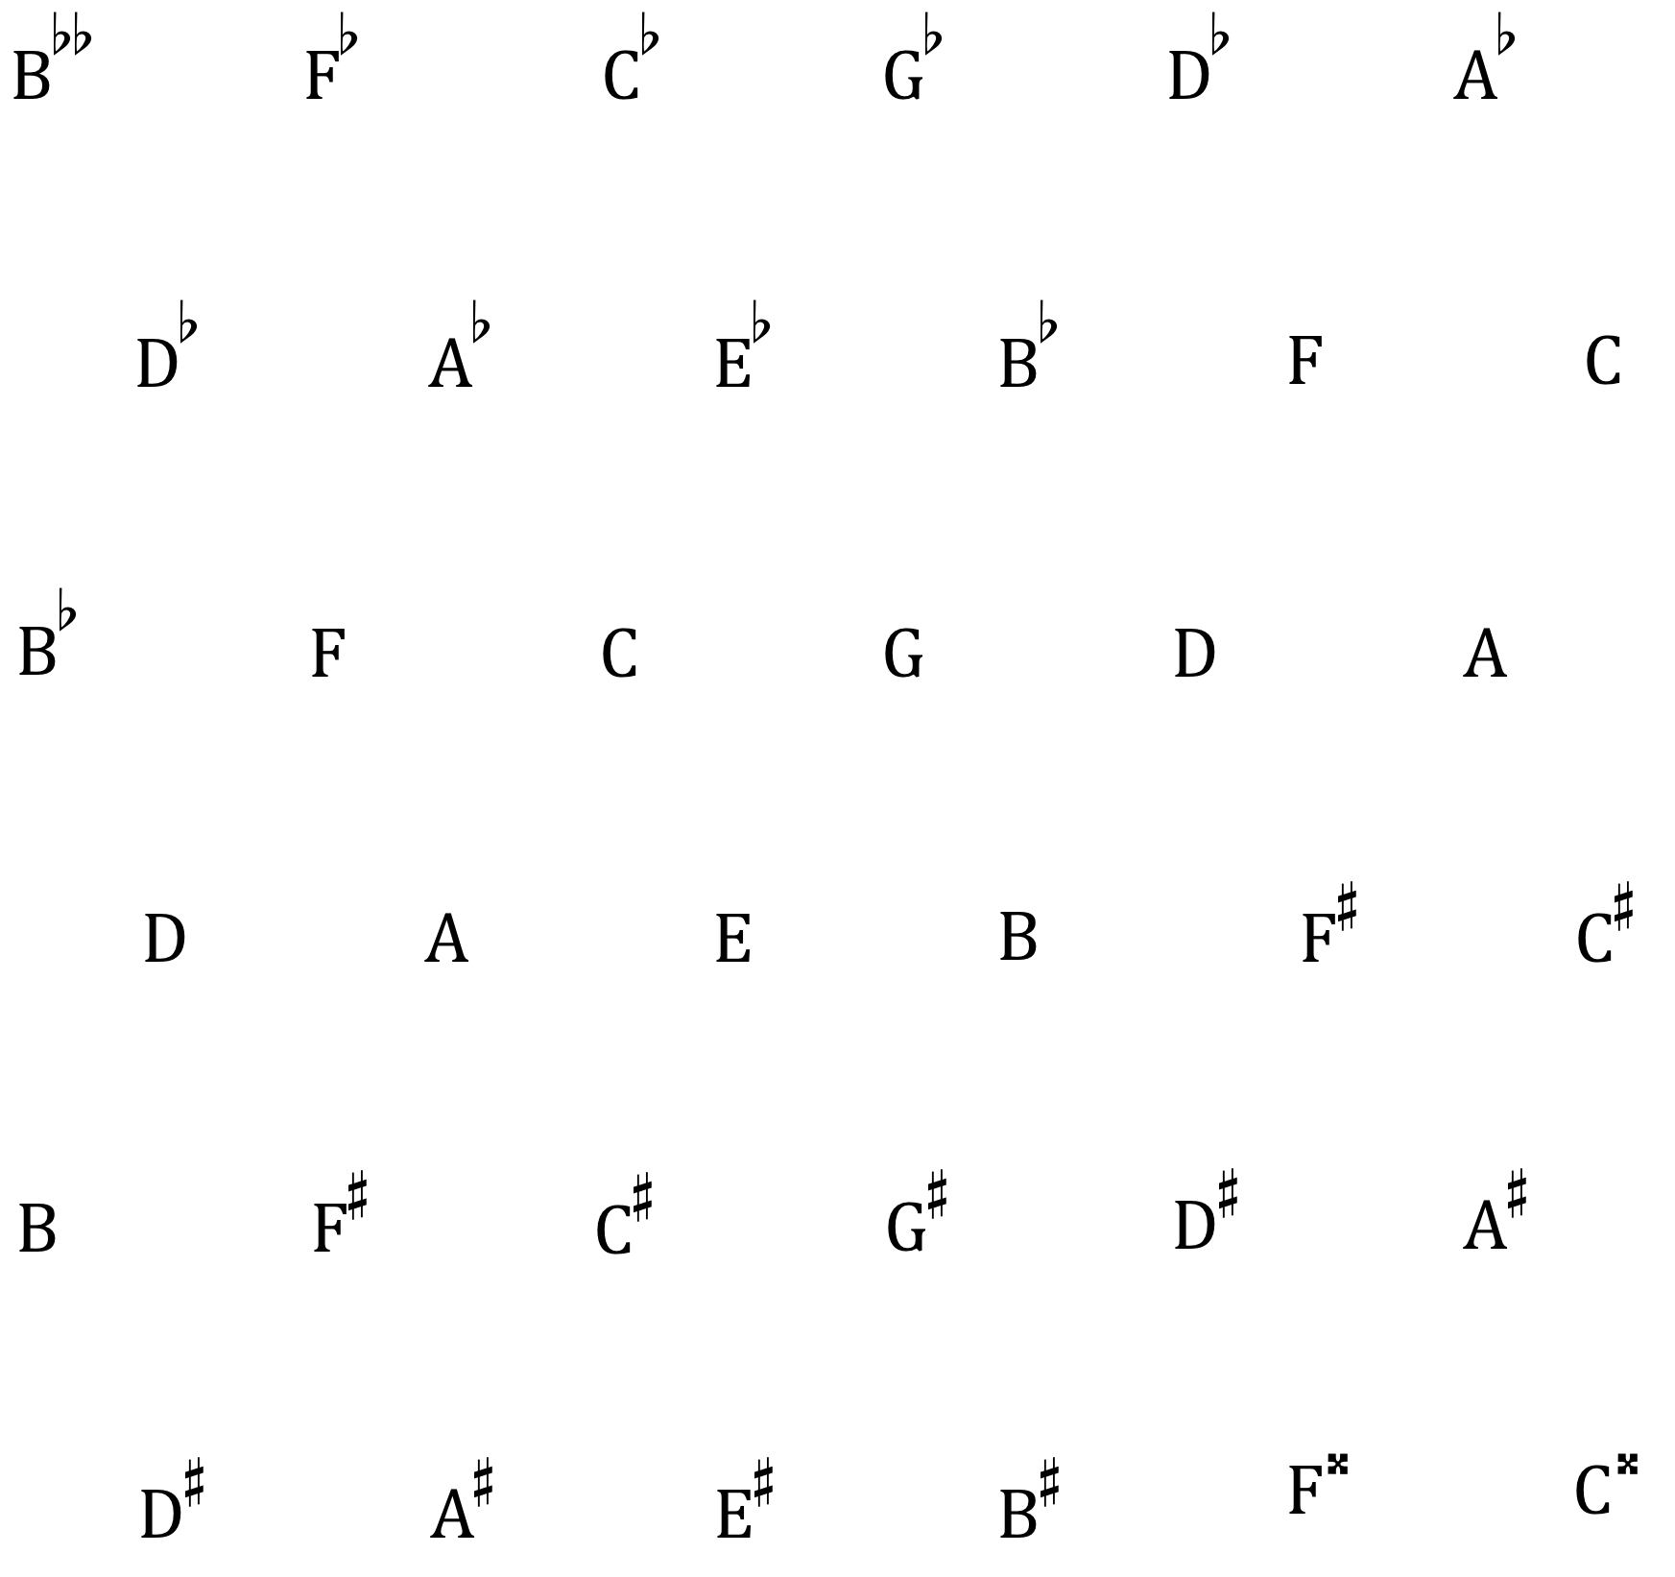

2. Identify the cycle in this reduction of Schubert’s Overture to Die Zauberharfe, opening Andante.

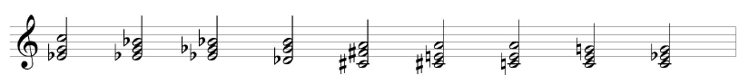

4. Bernard Herrmann, Summary of the “Prelude” for Vertigo (audio)

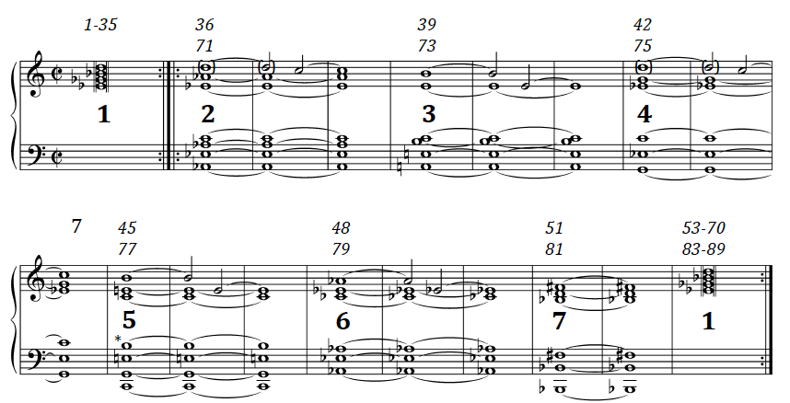

Analyze the familiar sound associated with the opening of Hitchcock’s Vertigo; ignore chord extensions (7ths and 9ths).

5. Alfred Schnittke, Hymnus II (for cello and double bass; audio)

This passage is not tonal in any conventional sense, but it can be understood as a series of major and minor triads. Use the contextual inversions L, P R and SLIDE to relate the triads to each other. You may wish to include an additional contextual transformation, one that would connect, for example, C major and D# minor. The voice leading between them is relatively smooth, but there are no common tones. Can you create groupings or clusters of triads related by these transformations? What patterns or connections do you see? Are there any small-scale or large-scale repetitions or transpositions?

What is the form of the excerpt? This will be a difficult question to answer in a simple way, because the form suggested by the texture and articulation is not the same as the form suggested by the relations among the triads.

In what sense is this piece a hymn, as the title suggests?

