Scelsi, assignment (alternate) on Quartet No. 4 (1964); due Feb. 1 Name

Scelsi’s Fourth Quartet is considered one of his finest works. Its one movement presents form as a gradual process: a steadily ascending band of pitches from around middle C to around A three ¹/₂ octaves higher, as indicated by the pitch-class and pitch reductions below.

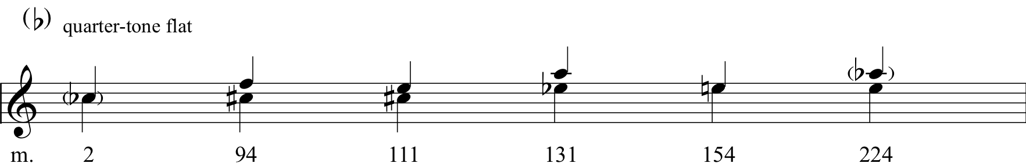

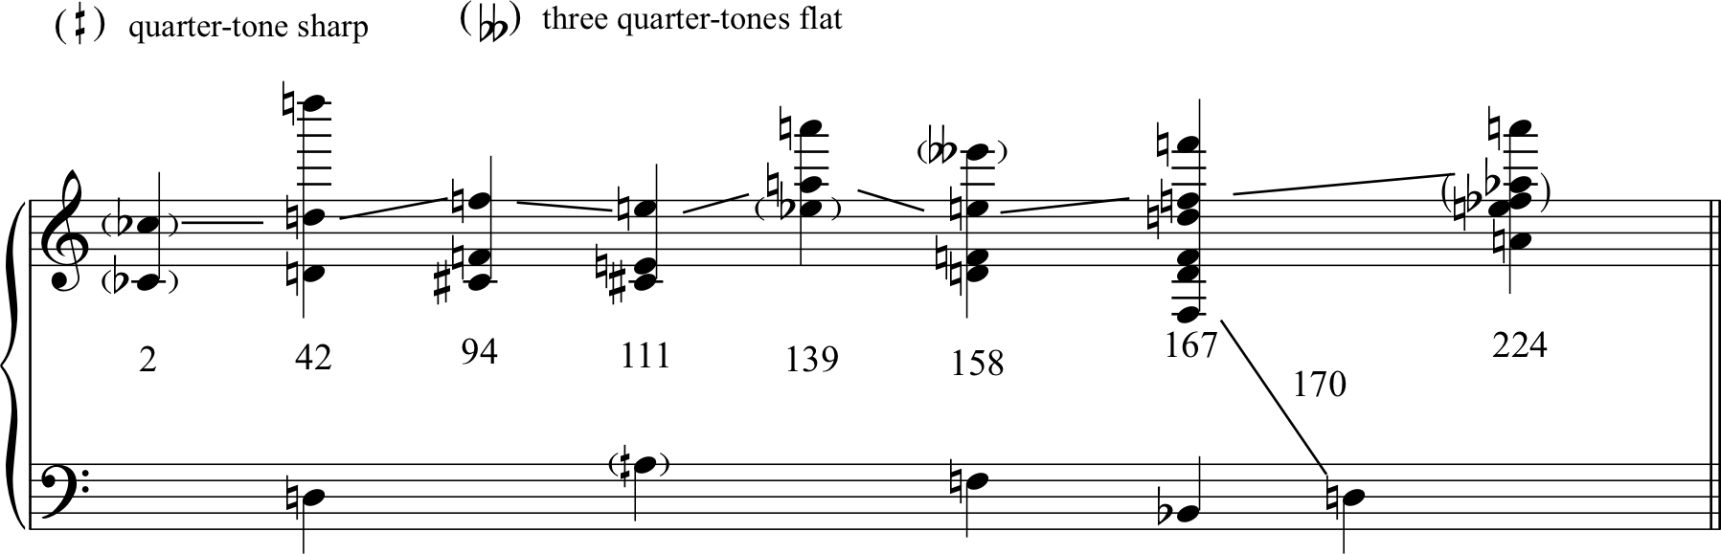

At the beginning the band seems like a magnification of a single drone pitch, but about midway through we hear a separation into two distinct bands centered on pitches a minor third apart (which continue to rise). Use both the score and the recording to answer the following questions about the Quartet. Pay attention to articulation, register, dynamics, etc. as well as pitch!

1. Give two reasons why it is difficult for the listener to distinguish these separate bands at the beginning of the quartet.

2. By what means is the C quarter-tone flat established as a focal pitch in mm. 1-8?

3. Where does the work first open up the third octave of the work (it occurs slightly after the 2’ mark on the recording)? How do you hear these doublings in relation to the lower pitches, and what contributes to that effect?

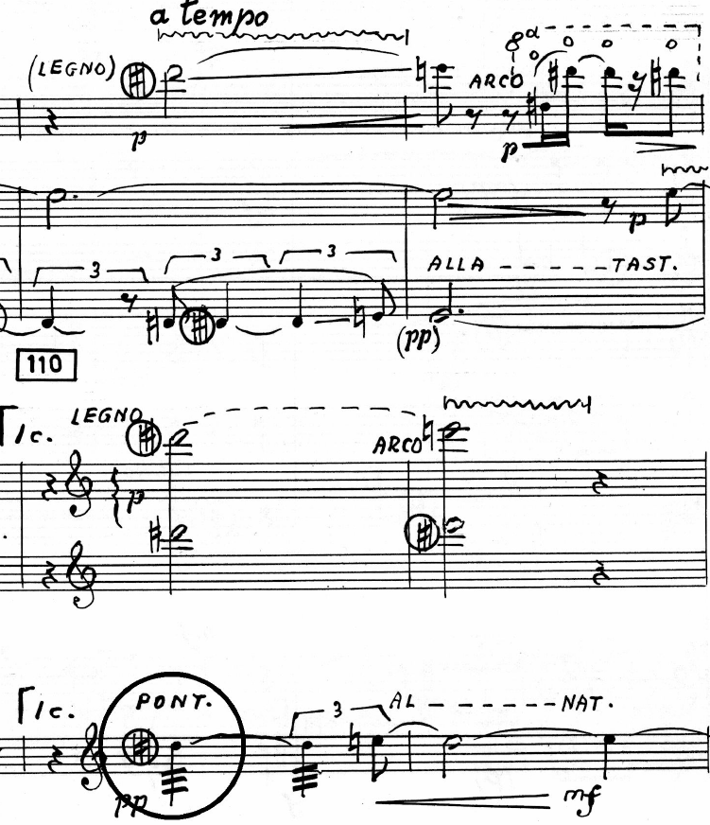

4. The arrival of E5 in m. 111 is a striking moment as shown at left. How is this E prepared as a goal? What happens in mm. 116 (slightly after the 7’ mark on the recording)? Do you hear this event as climactic or as part of an ongoing process? Why?

5. How do you here the final few bars of the work (after 13’45” in the recording) in relation to the intervallic and registral processes that preceded them?

