NAME:
Theory (63%)
Interval Cycles: Interval cycles result from the repeated transposition of a pitch class by a single interval.

1. Which interval cycles move through all twelve tones before returning to their starting point? (Hint: you learned this in the beginning of theory, there are two)

2. For which intervals are there two different cycles? (Two different pitch collections can be formed from the same interval cycle)

Three different cycles?

Four different cycles?

What are the familiar, traditional names for these collections?

II. Combination Cycles: Combination cycles involve the alternation of two different ordered pitch-class intervals.

1. Write out the following combination interval cycles starting on C.

a. <1, 6>

b. <1, 3>

c. <2, 5>

d. <3, 5>

2. For each of the following set classes, write out the three combination cycles for which every segmental trichord will be a member of that set class. As a hint, remember that the three combination cycles for (014) are <1, 3>, <1, 8>, and <3, 8>.

a. (015)

b. (026)
c. (013)

Ill. Transformational Voice Leading: Transformational voice leading arises from the mappings of pitch lasses resulting from Tn and In onto pitch-class sets.

For the following progression of trichords, identify the T or I that connect the chords and draw lines that connect the I pitch classes that are mapped by those transformations (all chords are members of sc(026)).

[Bb, D, E]⇒ [C#, F, G]⇒ [F, A, B] ⇒ [Eb, F, A] ⇒ [F, G, B] ⇒ [F#, Bb, C] ⇒ [Bb, D, E]

E | F | F | Eb | B | F# | E
Bb | G | A | F | F | Bb | Bb
D | C# | B | A | G | C | D

IV. Contextual Inversion: A contextual inversion inverts a set with reference to some particular feature of the set, usually involving inversion around (and retention of) a note or notes within the set.

Here are two contextual inversions for sc (0124): J = invert around the chromatic trichord (012); K = invert around the whole-tone dyad (024). For instance, The J inversion of [0124] = [T012], while its K inversion = [0234]

a. What is the J-inversion for [C#, D, Eb, F]?

For [F#, G#, A, Bb]?

For [G, Ab, A, B]?

b. Write out a chain of (0124) that begins on [C, D, D#, E] and alternates J and K. Are all twenty-four members of the set class in the chain?

2. Describe the contextual inversion that would account for both of the following pairs of sets in sc(013): [C, C#, D#] and [C#, D#, E]; [F, G, Ab] and [E, F, G].

V. Triadic Transformations: Major and minor triads can be connected with a variety of transformations that conjoin contextual inversion with voice-leading parsimony.

1. Apply triadic transformations as indicated:

a. P (A+) c. L (F#-) e. P (F-) g. L (Ab+)

b. R (C#-) d. SLIDE (F+) f. R (Bb+) h. SLIDE (G-)

2. Starting on the prescribed chord, list the harmonies that constitute the following cycles:

a. (Bb -): P ⇒R ⇒L ⇒P ⇒R ⇒L

b. (C#, +): L ⇒P ⇒R ⇒L⇒P ⇒R

c. Are any triads are shared by the two cycles?

3. Construct cycles of alternating major and minor triads as follows:

a. the L-P-cycle that includes G+

b. the L-P-cycle that includes F#-

e. the P-L-R—cycle whose triads all contain pitch-class A

d. the P–L–R-cycle that mcludes both D- and Db+

Analysis
I. Intervallic and Rhythmic Cycles. (25%) Attached is the concluding scene of an opera by Thomas Adès based on Shakespeare's The Tempest. The human characters have all departed, headed back home to Italy. Ariel, the "airy spirit" of the island, who had been acting as a servant to Prospero, has been set free and sings his pleasure in an untexted vocalise.

1. Analyze the voice part first. You will find statements of a series of eight notes. Number them 1-8 on the score, then study the series. How is it constructed intervallically?

What combination interval cycle is involved?

What type of collection do the eight notes represent?

2. There is a rhythmic pattern also, involving half and whole notes. How does this pattern line up with the notated meter?

3. The bass line uses the same series of eight notes. How does its presentation differ from the vocal line?

There is also a rhythmic pattern in quarter and half notes. How does it compare to the pattern in the vocal line?

To the notated meter?

4. Study the remaining notes and imagine them as forming a single line. The series operates here as well. And there is also a rhythmic pattern (easiest to see if you count in eighth notes). Compare the rhythm and pitch patterns to the voice and bass lines.

5. Think about the scene as a whole. In what ways are the patterns of pitch and rhythm coordinated? Are there points where they come together in some way?

II. Triadic Transformations. (12%) The following excerpts are taken from John Adams’ Nixon in China. Analyze the triadic relations between chords using P, L, R and SLIDE (NB: if a chord moves to one of the same mode, you will use a compound transformation; e.g. C+ to Eb+ = PR). Do you find any motions between hexatonic poles?
.
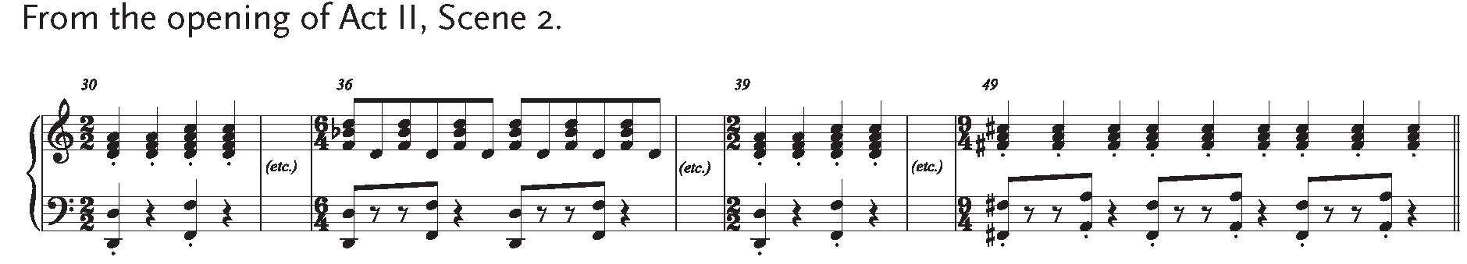

Act II, Scene 2
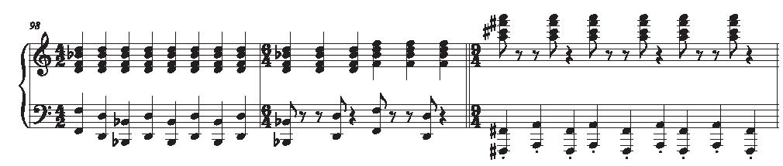

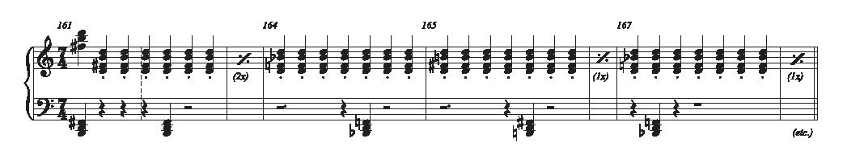
Act II, Scene 2

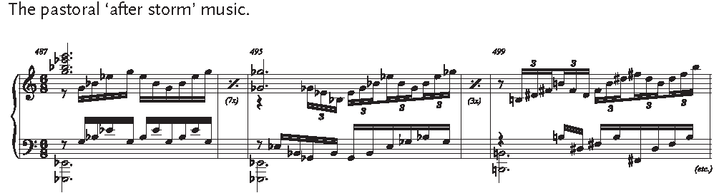

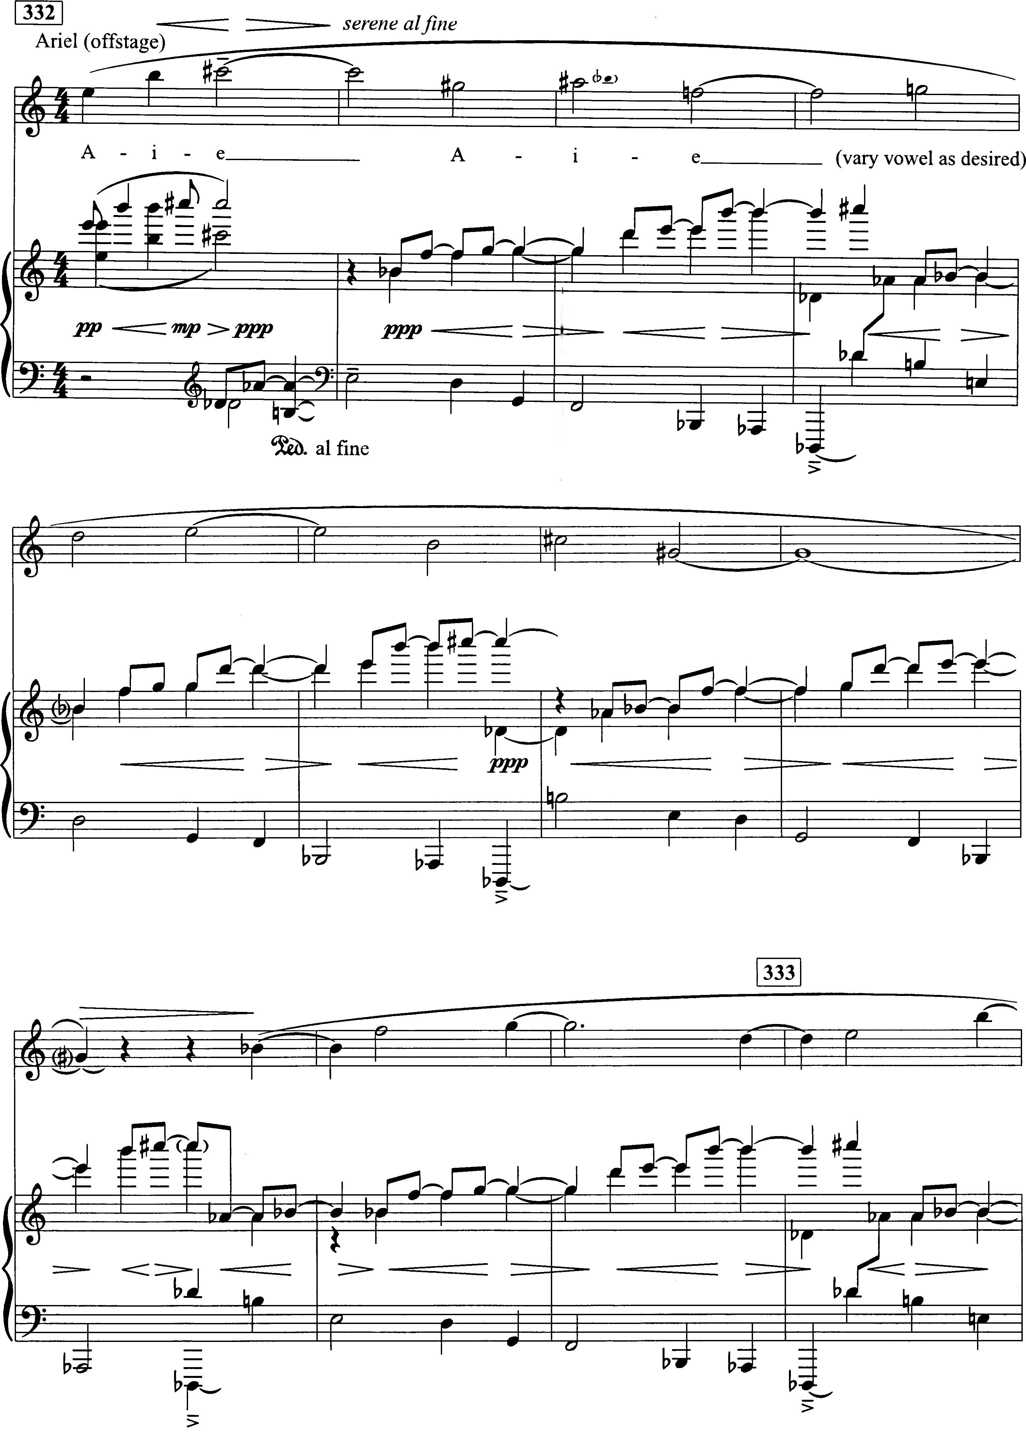
The Tempest, Act III, Scene V, coda

