Theory (50%)
I. Integer Notation: Any pitch can be represented by an integer. In the commonly used "fixed do'' notation, C = 0, C# = 1, D = 2, and so on.

1. Represent the following melodies as strings of integers:

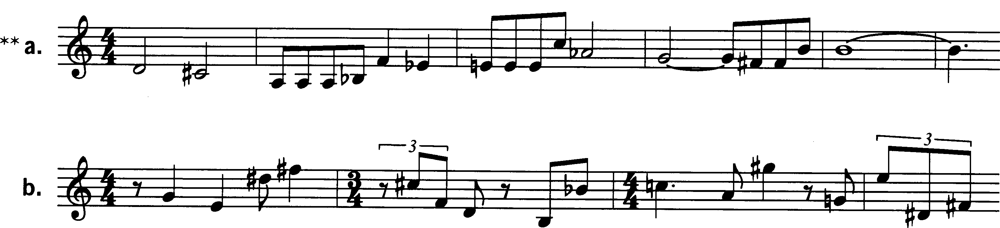

2. Show at least two ways each of the following strings of integers can be notated on a musical staff:

a. 0, 1, 3, 9, 2, 11, 4, 10, 7, 8, 5,6

b. 2, 4, 1, 2, 4, 6, 7, 6, 4, 2, 4, 2, 1, 2

II. Pitch Class and Mod 12: Pitches that are one or more octaves apart are equivalent members of a single pitch class. Because an octave contains twelve semitones, pitch classes can be discussed using arithmetic modulo 12 (mod 12), in which any integer larger than 11 or smaller than 0 can be reduced to an integer from 0 to 11 inclusive.

1. Using mod 12 arithmetic, reduce each of the following integers to an integer from 0 to 11:

a. 15 c. 49 e. -3 g. -15
b. 27 d. 13 f. -10

2. List at least three integers that are equivalent (mod 12) to each of the following integers:

a. 5 b. 7 c. 11

3. Perform the following additions (mod 12):

a. 6 + 6 b. 9+10 c. 4 + 9 d. 7+8

4. Perform the following subtractions (mod 12):

a. 9-10 b. 7-11 c. 2-10 d. 3-8

III. Intervals: Intervals are identified by the number of semitones they contain.

1. For each of the following traditional interval names, give the number of semitones in the interval:

a. major third c. augmented sixth e. minor ninth
b. perfect fifth d. diminished seventh f. major tenth

2. For each of the following numbers of semitones, give at least one traditional interval name:

a. 4 c. 9 e. 15

b. 6 d. 11 f. 24

IV. Ordered Pitch Intervals: A pitch interval is the interval between two pitches, counted in semitones. + indicates an ascending interval; - indicates a descending interval.

1. Construct the following ordered pitch intervals on a staff, using middle C as your starting point for each example.

a. +15 b. -7 c. -4 d. +23

2. Identify the ordered pi (=up or down) formed by each pair of adjacent notes.

V. UPI, OPI, IC.

1. Unordered Pitch Intervals: An unordered pitch interval is simply the space between two pitches, without regard to the order (ascending or descending) of the pitches. Construct the following unordered pitch intervals on a staff, using middle C as the lowest note for each example (C ->15, C-> 4, etc.).

a. 15 b. 4 c. 7 d. 11 e. 23
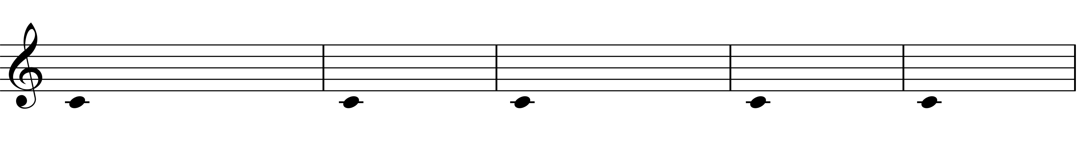

2. Ordered Pitch-Class Intervals: A pitch-class interval is the interval between two pitch classes. On the pitch class clockface, the first pitch class to the second.

Which ordered pitch-class intervals (no – or +) are formed by the following ordered pitch intervals?

a. +7 b. -7 c. +11 d. +13 e. -1 f. -6

3. Unordered Pitch-Class Intervals: An unordered pitch-class interval is the shortest distance between two pitch classes, regardless of the order in which they occur. Take the shortest route from the first pitch class to the second, either clockwise or counterclockwise on the pc clockface. An unordered pitch class interval is also called an interval class. Give at least two pitch intervals belonging to each of the six interval classes (i.e. using traditional tonal interval names).

1 | 2 | 3
4 | 5 | 6

VI. Interval Vector: Any sonority can be classified by the intervals it contains. The interval content is usually shown as a string of six numbers called an interval vector. The first number in the interval vector gives the number of occurrences of interval class 1; the second number gives the number of occurrences of interval class 2; and so on.

1. For each of the following collections of notes, give the interval-class content, expressed as an interval vector.

a. 0, 1, 3, 4, 6, 7, 9, 10 c. 2, 3, 7 e. the pentatonic scale
b. 0,2,4,6,8, 10 d. the augmented triad f. 1, 5, 8, 9

2. For each of the following interval vectors, try to construct the collection that it represents, starting on C.

a. 111000 b. 004002 c. 303630

Analysis (50%)

Igor Stravinsky, “Musick to heare,” Three Shakespeare Songs, mm. 1–8

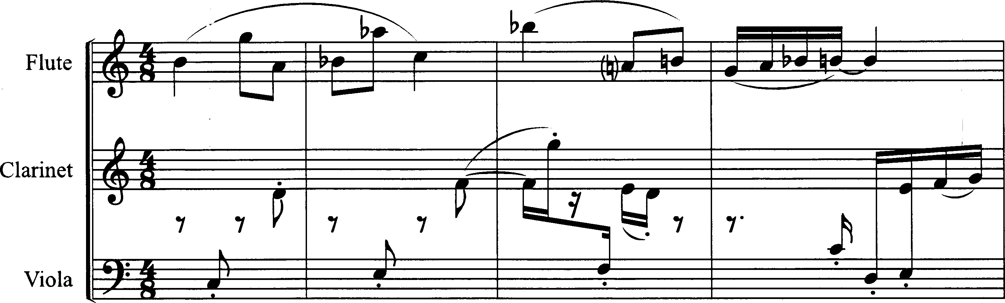

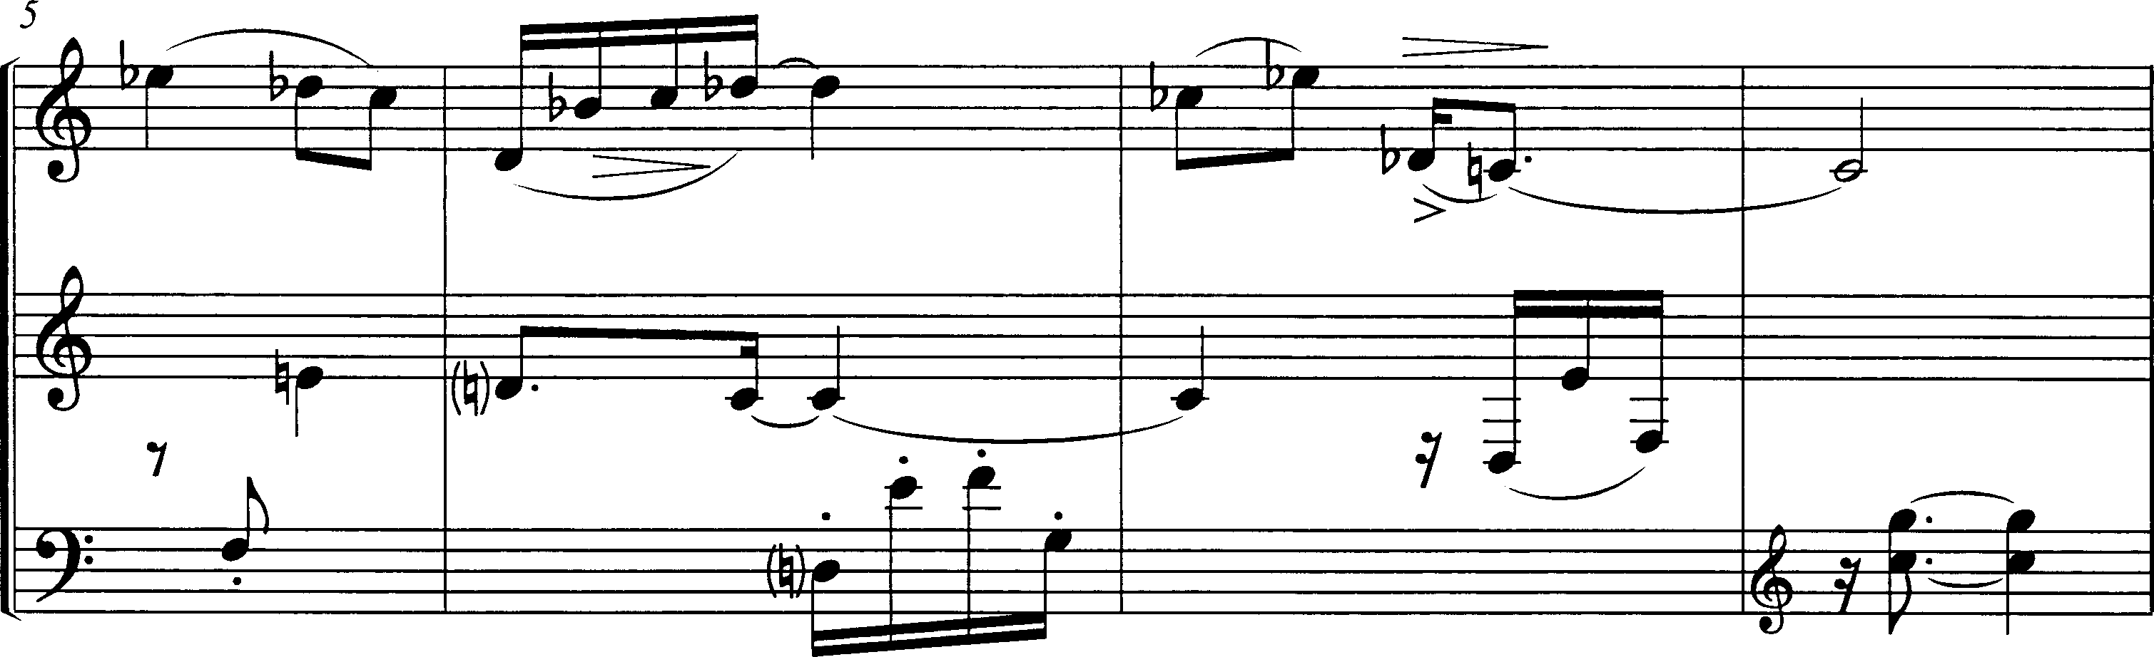

This is the instrumental introduction to a song scored for mezzo-soprano, flute, clarinet, and viola (all notes sound as written). The melody in the flute is sung by the voice when it enters, with changes in rhythm and register. In the instrumental introduction, a second melody, shared between clarinet and viola, provides a contrasting counterpoint.

1. Analyze the flute melody, identifying all its pitch and pitch-class intervals, and noting any recurrences. Although the phrasing slurs don't suggest this, you may want to consider the first four notes, B-G-A-B^{b}, as comprising a basic motive. Think about it as an ordered series of pitch classes, defined by its ordered pitch-class intervals. Focus on the relations among the four-note groups in the melody, beginning with that first group.

2. Thinking about the larger shape of the melody, can you find a trasnpositional or inteversional relationship between the first half of the melody (the first three four-note groups) and the second half (the last three four-note groups)?

3. The phrasing, rhythm, and registral design of the flute melody seems to contradict rather than reinforce the underlying four-note groups. What is the expressive effect of that contradiction?

4, In the pitch groupings that are created by phrasing, rhythm, or register (like the high G-A^{b}-B^{b} in measures 1-3, for example), can you find any relationship to the intervals in the underlying four-note groups?

5. Describe the organization of the other melody, shared between the clarinet and viola.
What familiar structure does it traverse?

6. Despite its obvious contrast with the flute melody, what sorts of intervallic ideas do the two melodies share?

7. This song is a musical setting of a sonnet by Shakespeare. In it, the narrator encourages his friend to get married, arguing that a man and a woman are like two sounding strings on an instrument—they are different, but if properly tuned to each other, beautiful sounds can result:

If the true concord of well-tuned sounds,
By unions married, do offend thine ear,
They do but sweetly chide thee, who confounds
In singleness the parts that thou shouldst bear.

What is there in the relationship between the two melodies in measures 1-8 that might be expressive of such a text? In answering, you might think about the ways that the contrasting melodies have a mutual interest in the interval C-G.

Edgard Varèse, Octandre, I, mm. 1–6.

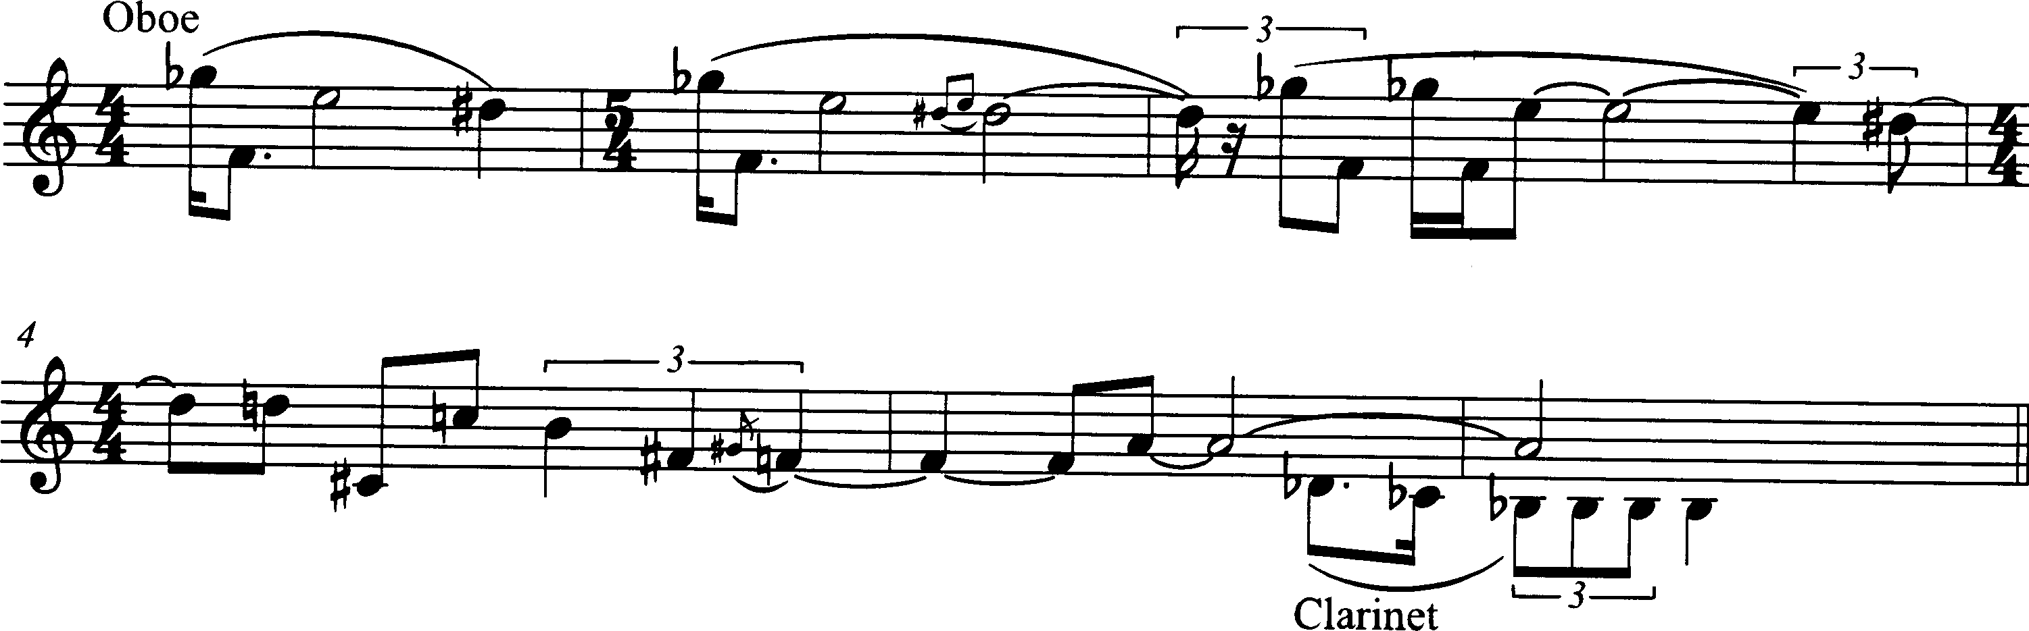

This is the quiet opening of an increasingly wild octet for flute, oboe, clarinet, bassoon, French horn, trumpet, trombone, and contrabass. It starts as though frozen in place, and then gradually melts and starts to move downward, becoming increasingly animated melodically and rhythmically. Along the way, virtually all of the pitches between the initial G^{b} in the oboe and the final B^{b} in the clarinet are at least touched on.

8. You can think of the first measure as a simple three-note motive—intervallically < -2, -1>—punctuated with a big leap to a lower register. Or you can think of it as a four-note idea that fills the chromatic space G^{b}—F—E—D#. Either way, can you find recurrences of the motive, either in its original order, or possibly reordered?

9. How do the phrasing and registers of the melody reveal or conceal the motive statements?

