NAME:
Theory (55%)
I. Basic Operations: A series is traditionally used in four different orderings: prime (P), inversion (I), retrograde (R), and retrograde-inversion (RI). Each of these four orderings may begin on any of the twelve pitch classes. Use the following twelve-tone series in answering the succeeding questions, and assume that each one is a P-form.
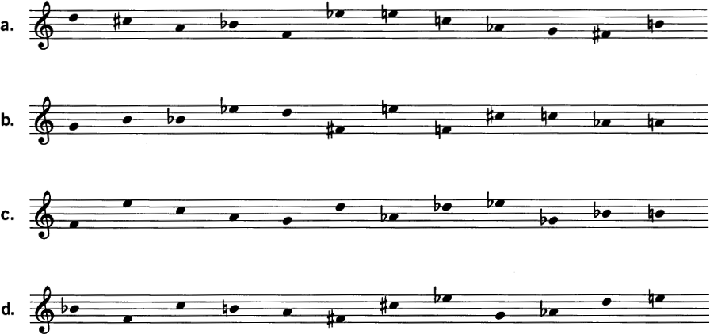
1. For each of the notated series, write the following series forms. (Give your answer both in integers and in staff notation.)
a. P₇
b. R₁₀
c. RI₆
d. I₅
2. Each of the following series is a transformation of one of the four given above. Identify the series and the transformation.
a. 7, 6, 2, 11, 9, 4, 10, 3, 5, 8, 0, 1 :
b. 3, 4, 8, 7, 0, 2, 1, 5, 9, 10, 11, 6 :
c. 4, 6, 0, 1, 5, 7, 2, 11, 9, 8, 3, 10 :
d. 8, 7, 11, 0, 4, 3, 5, 1, 2, 9, 10, 6 :

3. For each of the notated series, construct a 12 X 12 matrix. Using the matrix, check your answers to the previous questions.
a | b
c | d

4. Indicate whether the following statements are true or false. (If false, make the necessary correction.)
a. The prime and retrograde-inversion have the same intervals in reverse order.
b. The inversion and retrograde-inversion have complementary intervals in reverse order.
c. The retrograde and inversion have complementary intervals in the same order.
II. Subset Structure: The constituent groupings within a series are its subsets.
1. For each of the notated series, identify the set classes to which the following belong:
a. the discrete trichords
a. b. c. d.
b. the discrete tetrachords
a. b. c. d.
c. the discrete hexachords
a. b. c. d.
III. Invariants: Any musical object or relationship preserved under some operation is an invariant.
1. For the series from Schoenberg's String Quartet No. 4, (D–C#–A–B^{b}–F–E^{b}–E–C–A^{b}–G–F#–B), identify the series forms that preserve the following segments:
a. (G, F#, B) b. (B^{b}, F, E^{b}) c. (D, C#, A, B^{b})

2. For the series from Webern's Concerto for Nine Instruments, op. 24, (G–B–B^{b}–E^{b}–D–F#–E–F–C#–C–A^{b}–A), identify the series forms that preserve the discrete trichords.

IV. Derivation: A derived series is one whose discrete segmental trichords or tetrachords are all members of the same set class.
1. The following series by Webern are derived. Identify the generating trichord or tetrachord and the transformations (transposition, inversion, retrograde) that connect it with the other segmental subsets of the series.
a. C#–C–E^{b}–D–F#–G–E–F–A–A^{b}–B–B^{b} (String Quartet, op. 28)
b. E^{b}–B–D–C#–F–E–G–F#–B^{b}–A–C–A^{b} (Cantata I, op. 29)

Analysis. Dallapiccola, Goethe Lieder, No. 2, “Die Sonne kommt!” (25%)
1. Take the first twelve notes in the voice as the twelve-tone series for the piece: P₈ = G#–A–G–F–B–E–D–E^{b}–B^{b}–D^{b}–C–F#. Analyze the series, with particular attention to its intervals and discrete trichords. Without constructing a 12 X 12 matrix, identify the remaining series forms in the piece below as they appear.

2. What is the overall shape and form of the vocal melody?

3. How do the third and fourth series forms relate to the first and second? How is this relationship reflected in the rhythm?

4. The vocal line uses only two series forms (and their retrogrades). What segmental invariance links them together?

5. How does the clarinet accompaniment relate to the vocal melody in pitch and in rhythm?

6. Look at the intervals and collections formed by combining notes in the melody with simul-taneously sounding notes in the accompaniment. Can you relate them in any way to intervals or collections found within the melody?

Webern, Concerto for Nine Instruments, Op. 24, iii, mm. 1–13 (20%)
The second movement of this concerto has been discussed many times in this book. The third movement, excerpted here, maintains the intervallic and trichordal focus of movement ii.

1. P₅ = F–F#–D–C#–A–B^{b}–A^{b}–C–B–E–E^{b}–G. Analyze the series, with particular attention to its intervals, discrete trichords, and hexachords. Do a twelve-count of the passage, identifying its row forms.

2. The series is derived from a trichord. Identify occurrences of that trichord and relate them via T_{n} and I_{n} . Do you see any patterns?

3. The passage can be thought of as two separate lines (as in the reduced score). Analyze the relationship between the lines, both in pitch and in rhythm.

4. Study the invariance among the series forms and describe how it is manifested in the music.

5. Other than the poco ritenuto and the rest at the end, what gives this passage the sense of a single formal section, with a beginning, middle, and end?

