NAME:
Theory (85%)

I. Common tones under transposition (T_{n}) (refer to the text, p. 132, for help with the no. of pitch classes held in common when a set is transposed by a given interval can be determined from the ICV) (20%)

1. Using the List of Set Classes, find the following:

a. tetrachords that retain two common tones at T₂:

b. pentachords that retain two common tones at T₄:

c. hexachords that retain two common tones at T₆:

2. For each of the following sets (given in NF) determine the number of common tones at T₁, T₄ and T₆, and identify the tones held in common.

a. [3, 4, 5] transposition common tones

T₁
T₄
T₆

b. [1, 3, 7, 9]

T₁
T₄
T₆

c. [2, 3, 6, 7. 10, 11]

T₁
T₄
T₆

d. [1, 5, 7, 8]

T₁
T₄
T₆

3. Which of the following pc sets are transpositionally symmetrical? If the pc set is transpositionally symmetrical, at what T_{n} level other than T₀ does it map onto itself?

a. [F, G, B, C#]
b. [B, C, D#, G]
c. [A, B^{b}, B, E^{b}, E, F]
d. [C#, F, A]
II. Common Tones under Inversion (I_{n}) (Refer to your text on p. 133 to determine this from the addition tables). (14%)

1. Construct addition tables for the following sets (given in NF):

a. [4, 5, 7, 8, 0]

b. [6, 8, 9, 10, 11, 1]

c. [1, 3, 7, 8]

2. For each of the sets in II.1, how many common tones will there be at the following I-levels, and which tones will be held in common?

a. [4, 5, 7, 8, 0] I₂: I₄: I₉

b. [6, 8, 9, 10, 11, 1] I₂: I₄: I₉

c. [1, 3, 7, 8] I₂: I₄: I₉

d. [5, 8, 11, 1] I₂: I₄: I₉
3. Some sets map onto themselves under inversion (i.e. are inversionally symmetrical). Do any of the sets below fit that description? If so, at what index of inversion (I_{n})? You may use a clock face or matrix to determine this, but just list the answer.

a. [A, B^{b}, B, C, C#, D]

b. [C#, D, E, F#, A, B^{b}]

c. [G, A^{b}, D^{b}, D]

d. [B, C, D, E, F, G, A]

III. Set-class membership. The number of sets in a sc = 24 divided by the number of operations that maps the set onto itself (including T₀). (10%)

1. Which tetrachords have fewer than 24 members?

Which have fewer than 12 members?

Which set-class has the fewest members of all?

2. For the following set classes, specify the number of sets in each and the number of operations that will map the set onto itself?

No. distinct members operations that map text to itself degree of symmetry
a. (024)

b. (0167)

c. 0369)

d. (012678)

IV. Z-relation. Two sets that are not members of the same sc yet have the same interval vector.(4%)

1. Indentify the Z-correspondent of each set class (give the Forte name and the prime form):

- 4-z15 (0146)

- 5-z37 (03458)

- 6-z6 (012567)

- 6-z44 (012569)

2. Identify the two Z-related sets that share each of the following interval vectors.

a. 222121 c. 224322
b. 111111 d. 433221
V. Complement relation. For any set, the pcs it excludes represent its complement. Sets that aren’t literal complements may still be members of complement-related scs. (4%)

1. Complement related set-classes have a proportional distribution of ics (beware the tritone!). The interval vector is provided for each of the following sc. Figure out the ICV of its complement without looking at the list of set-classes:

a. 3-3 (014) [101100]

b. 4-18 (0147) [102111]

c. 8-27 (0124578T) [456553]

d. 7-z12 (0123479) [444342]

2. To find the prime form of a collection of more than 6 notes, write out that complement, find its prime form, and look it up (e.g., if you have 8 notes, find the 4 missing ones). You will find the PF across from this in the list. Use this method to find the PF for the following sets:

a. 0134569T c. 01245679E

b. 123468T d. 01245679E

VI. Subsets. If set-class X is included in set-class Y, X is a subset of Y/Y is a superset of X (9%)

1. For each set below extract all 3-note subsets, put them in NF and identify their PF (tetrachords will have 4 trichordal subsets, while pentachords have 10).

a. [0167] [ ] [ ] [ ] [ ]

( ) ( ) ( ) ( )

b. [0148] [ ] [ ] [ ] [ ]

( ) ( ) ( ) ( )

c. [01369] [ ] [ ] [ ] [ ] [ ]

( ) ( ) ( ) ( ) ( )

[ ] [ ] [ ] [ ] [ ]

( ) ( ) ( ) ( ) ( )

2. Answer these questions about some familiar large collections:

- How many major or minor triads are contained in the octatonic collection (0134679T)?

b. The major scale contains the most occurrences of which trichord?

c. The three-note subsets of the whole-tone collection are members of how many different set-classes?

VII. Transpositional Combination. (8%)

1. Combine each of the sets below with a transposition of itself to create a larger set (with no common tones between them). By changing the level of transposition you can create different supersets. How many different kinds of larger sets can you create? Give their normal and prime forms.
a.
NF | T_{n} | TC set | Set-class
[C, D, F]
[C, D, F]
[C, D, F]

b.
[D, A]
[D, A]
[D, A]
[D, A]
[D, A]

c.
[F, A, C]
[F, A, C]
[F, A, C]

2. All of the following sets have the TC property. Divide them into their transpositionally-related subsets (there may be more than one division possible)

- [B, C, E, G]

- [E, F, G, A^{b}]

- [G, A^{b}, B^{b}, D^{b}, D, E]

VIII. Special Set Classes (4%)

1. (012478) is known as the “all-trichord hexachord,” because it includes at least on instance of each trichord type. Extract all of the trichords from this set as given, and show both their normal and prime form (you may continue on p. 6)

2. Identify the only set (a hexachord) with transpositional but not inversional symmetry.

3. Which trichord has the highest degree of transpositional and inversional symmetry?

Which tetrachord? Which hexachord?

IX. Contour. Contours can be described with CSEGS: ordered series of numbers where 0 indicates the lowest note, etc. CSEGS form a class based on the operations of inversion, retrograde and retrograde inversion. (12%)

1. Write five musical realizations of CSEG <0132> below.

2. Identify the prime form and remaining members of the CSEG class for the following CSEGS:

a. <1230>

b. <3021>

3. For the following melody from Crawford Seeger’s Diaphonic Suite No. 1, ii, identify the CSEG ad CSEG-class for each bracketed segment.
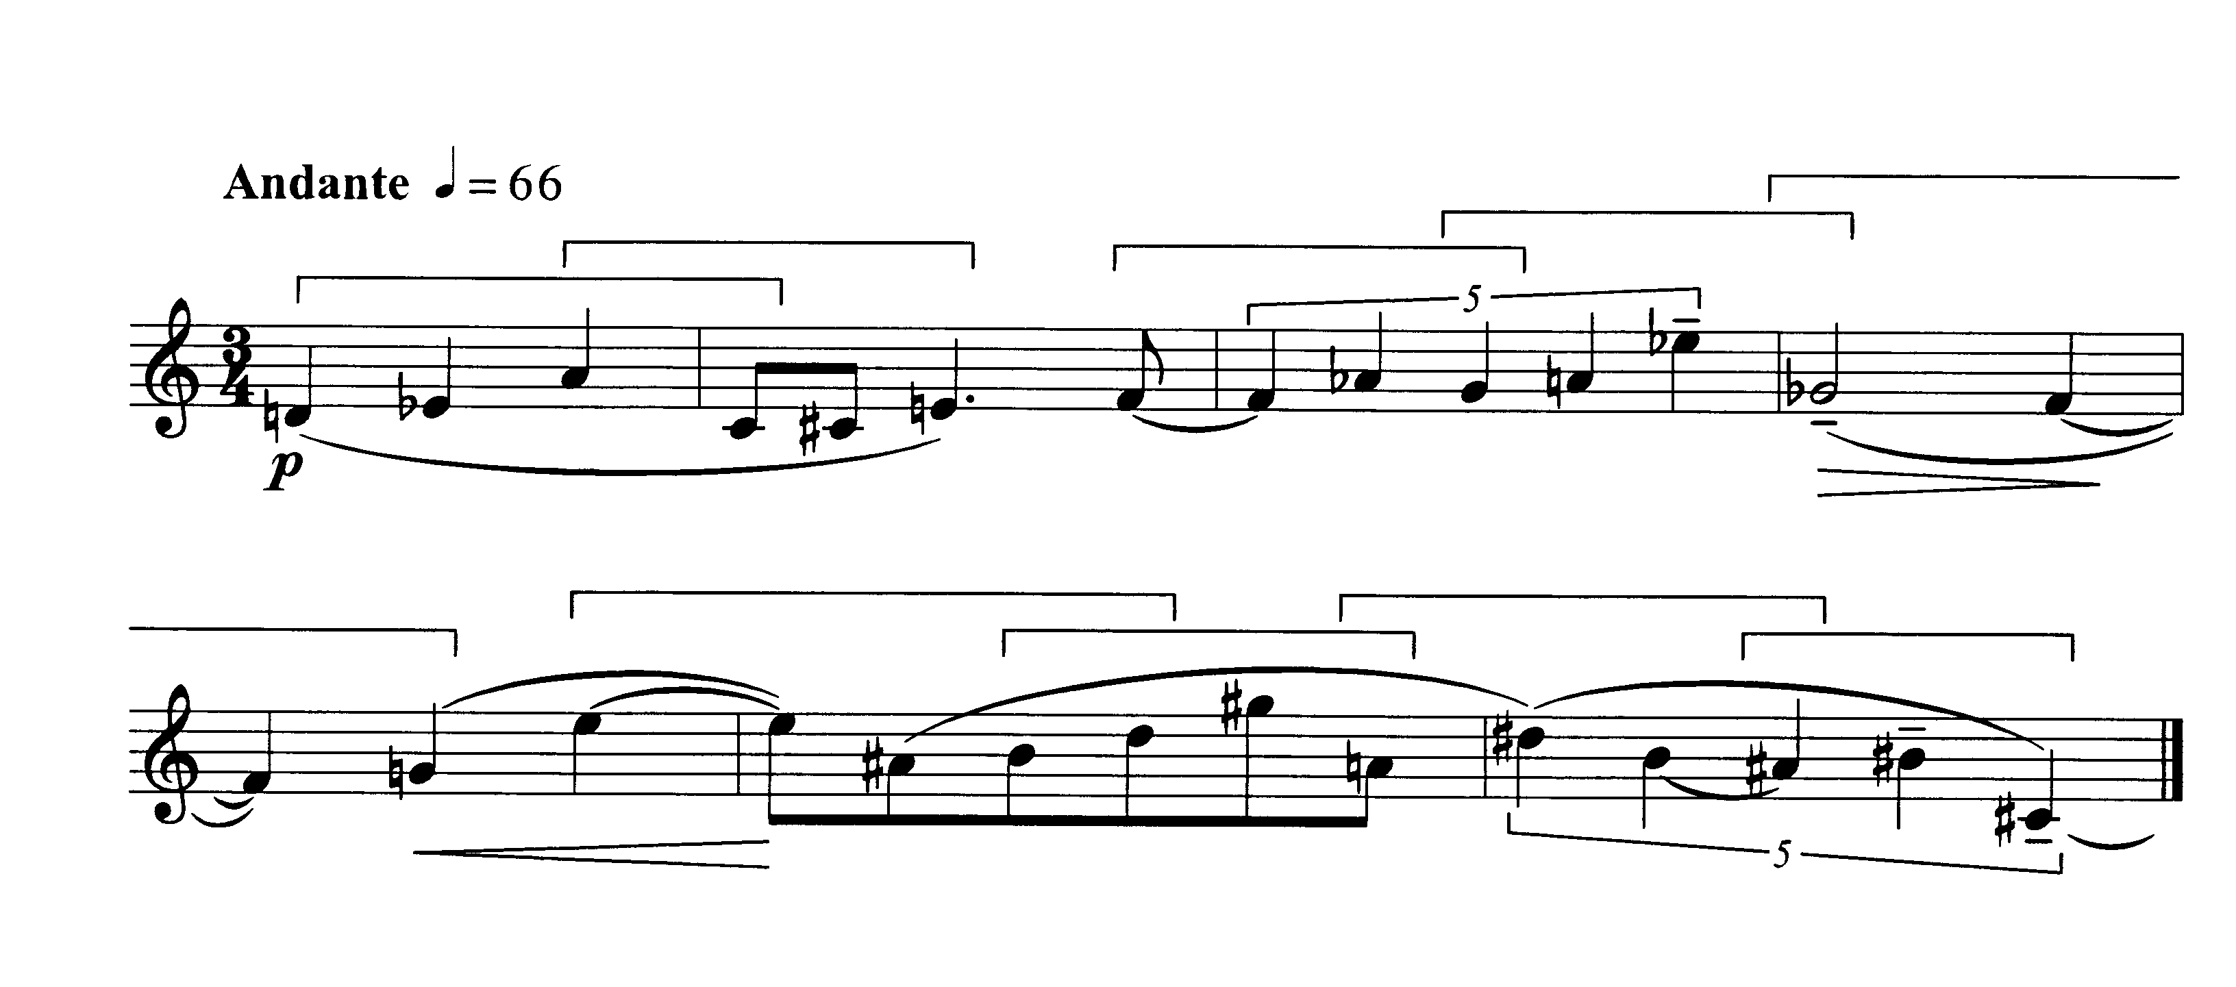

Analysis (15%)

György Ligeti, Étude 11: En suspens, mm. 1–15

1. Until the left hand plays a scale, each hand contains only six different notes. Put each hexachord in normal form and compare them. Which set class do they represent?

What is the relationship between them?

2. How are the hexachords presented musically; are there differences between right and left hand?

3. The two hands also contrast in rhythm and meters. Can you relate the differences in pitch and rhythm to the work’s title, “in suspense”?

The right hand has a regular rhythmic pattern that lasts for 24 beats and a rest. This is further subdivided into groups of 9 + 10 + 5, each section composed of duple or triple subdivisions. Trace this pattern throughout the passage. How does it line up with the notated meter?

