NAME:
Theory (55%)
I. lnversional Axis: Inversionally symmetrical sets map to themselves under I_{n}. On the pitch-class clockface, the axis of symmetry for such a set runs through n/2-n/2 + 6.
1. For each of the following sets, determine if they are inversionally symmetrical. If they are, find the axis (or axes) of symmetry. (You may find it helpful to write these sets around the pitch-class clockface).
a. [1, 4, 5, 8] d. [9, 10, 11, 3, 5]
b. [10, 0, 1, 2, 4] e. [4, 6, 11]
c. [1, 2, 3, 4, 8, 9] f. [1, 2, 5, 6, 9, 10]

2. Construct at least two pitch-class sets that are symmetrical around the following axis (or axes). Give your answer in normal form.
a. 4—10 c. 1—7
b. 2/3—8/9 d. 1—7 and 4—10 (find sets that works with both)

II. Referential Collections
1. For each of the large collections discussed in this chapter (the diatonic, octatonic, whole-tone, and hexatonic collections), do the following:
a. Compare their interval vectors. Which interval classes are maximized (appear the most)? Minimized?
 | Maximal intervals | Minimal intervals
Diatonic
Octatonic
Whole-tone
Hexatonic
b. Compare them with regard to transpositional and inversional symmetry. Which are the most symmetrical? The least symmetrical?

2. Write out the following scales.
a. D Mixolydian

b. E^{b} Phrygian

c. G# Locrian

d. OCT_{0,1} beginning on G

e. OCT_{1,2} beginning on G

f. WT₁ beginning on B

g. HEX_{1,2} beginning on A
3. Identify each of the following collections, using nomenclature presented in this chapter:
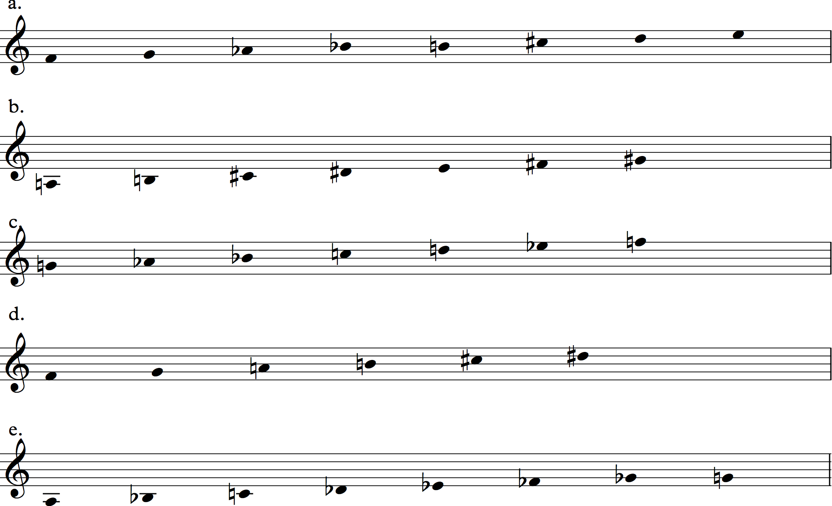

4. For each of the following sets, identify the specific DIA, OCT, HEX, and WT collections that contain them (NB: there will be at least 2
a. [D, F#, A, C] d. [E, G, G#, B]
b. [C#, E, G, B^{b}] e. [D, E, G#]
c. [E, F#, B^{b}, C]

Analysis, Stravinsky, Oedipus Rex, Reh. Nos. 167–70 (22%)
In the Oedipus story, this is the moment that the doomed protagonist realizes that he has unwittingly transgressed divine law by killing his father and marrying his mother:
Natus sum quo nefastum est,  concubui cui nefastum est,  kekidi quem nefastum est,  Lux facta est! | I was born of whom divine law forbade,  I married whom divine law forbade,  I killed whom divine law forbade,  All is now made clear!
In the music that precedes this passage, a shepherd and a messenger reveal the horrible truth in a kind of static recitation that uses D Dorian and centers on the triad D-F-A and on pitch­ class D. Oedipus is a more complicated character, however, and as he prepares to speak, the music becomes correspondingly more complex.
1. There are D-centered and B-centered elements throughout the passage: pitches, triads, and diatonic collections. Describe the B-D tension throughout the passage, and observe the musical clashes it engenders.

2. What role does OCT_{2,3} play in the passage?

3. The passage ends on a dyad, D-F#. How is it approached? How does it function musically in relation to the prevailing clash of B-minor and D-minor triads?

4. How does the music reflect the text and the dramatic situation? Is there a musical sense that “All is now made clear”?

Bartók, Mikrokosmos, “From the Island of Bali” (23%)
5. What is the form of this piece? How is the form articulated? (Hint: look at collections and texture]

6. What is the role of OCT_{2,3} as a source of pitch materials for this piece? What notes do not belong to this collection? How would you explain them?

7. The third of the four sections of this piece is not octatonic. How would you relate its pitch material to the other three sections, which are octatonic?

8. What is the role of inversional symmetry in shaping this piece, especially in the relationship between the two hands, which are often mirror images of each other?

